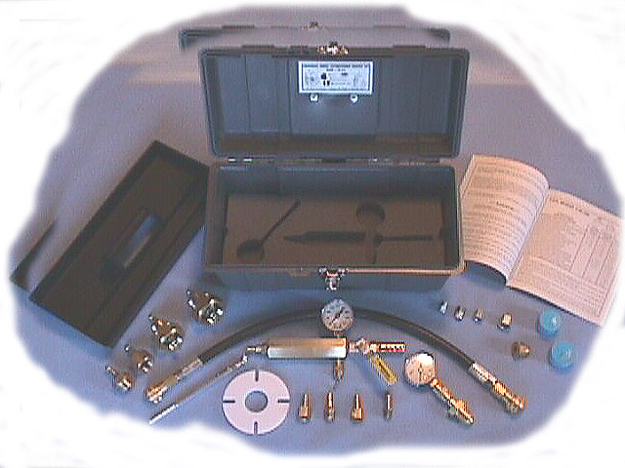
WSK30350
Universal “Wheeled Extinguisher” Service Kit

The only kit used and recommended by fire equipment manufacturers!

Flow Chamber: P/N-01250 The flow chamber is designed to allow the quick and simple on site field testing of pressure regulators. It permits service technicians to determine proper regulator dead-set and minimum flow capacity readings. This proprietary designed flow chamber is made from quality brass and machined to tight tolerances to ensure accurate readings. It features a quality metal cased pressure gauge, special steel quick connect adapter connection, self re-setting spring loaded safety relief, quality plated brass ball valve with Teflon seat and a pressure diffusion muffler to safely vent test pressures.
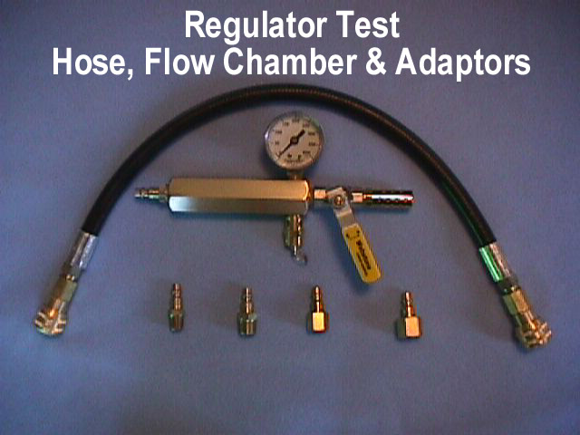

Test Hose Assembly: P/N-01410 This hose assembly provides service technicians with a quick and simple means to perform various operational tests and agent hose clearing functions. The test hose assembly measures 24 inches and is made from a quality high-pressure wire braided hose, having a special pin pricked outer wrap for trouble free use. Each end of the test hose assembly features a special high quality “quick-connect” fittings for safety and extended service.

Quick Connect Adapter Set: P/N-01740 Various sizes of quick connect adapters allow service technicians to address a wide variety of extinguisher model fittings and connections. The quality steel adapters feature a special protective plating to ensure a longer service life.

Agent Hose Adapter Set: P/N-01455 The agent hose adapters permit service technicians to perform agent hose clearing and nozzle valve leakage checks, as well as other maintenance functions associated with pick-up tube clearing functions. The unique design saves time and will accommodate both the male and female couplings on the 1”, ¾” and ½” nominal extinguisher agent hose sizes. The adapter set is all machined to tight tolerances from quality brass. Each agent hose adapter is fitted with the proper pressure retention gasket and equipped with quality plated steel quick connect adapters for use with the kit test hose assembly.
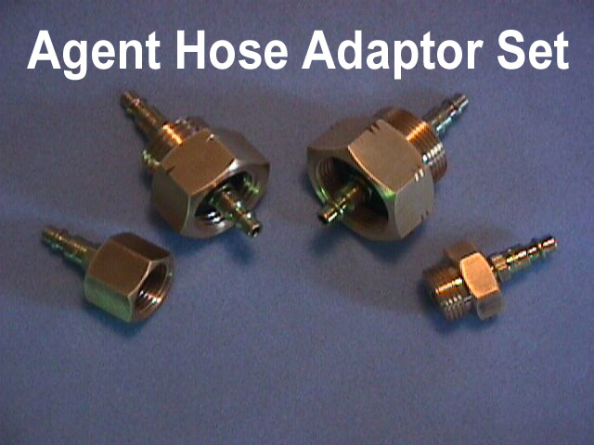
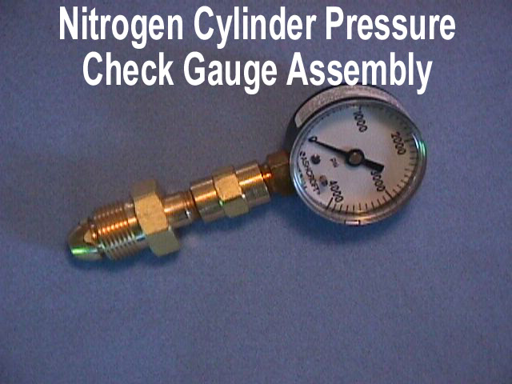
Check Gauge Assembly: P/N-01300 This assembly provides the service technician with a quick and simple means to not only verify the nitrogen cylinder charge pressure, but also the proper function of the cylinder valve during annual maintenance. The check gauge assembly features a quality metal cased pressure gauge, special high pressure brass hardware fitting and the proper CGA threaded adapter for the type of nitrogen cylinder valves utilized within the fire protection industry.

Vent Spacer: P/N-01530 The vent spacer is designed to allow service technicians a safe and simple means to slowly vent the agent cylinder pressure when performing fill cap, gas tube and siphon tube clearing durable, high-density polyethylene which will not scratch or damage the fill cap or agent cylinder seating surfaces.
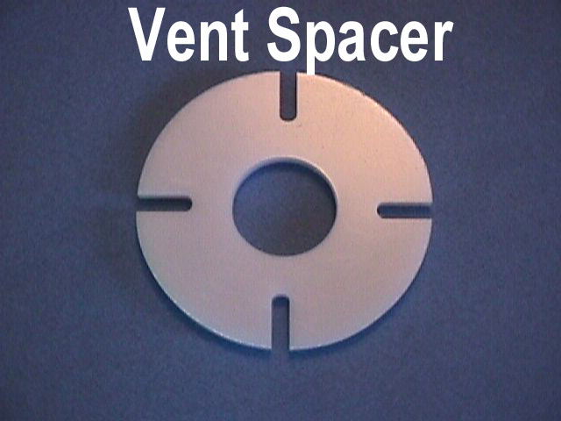

Nitrogen Cylinder Valve Vent Plug: P/N-01560 The cylinder valve vent plug reduces the thrust and velocity created by the rapid discharge of high pressure from the nitrogen cylinder, should the cylinder valve’s “Quick-Opening Lever” ever be accidentally tripped during service. For safety reasons service technicians should never attempt to work around these types of cylinder valves without first installing this vent plug. The vent plug is machined from quality brass to tight specifications and features an external hex fitting to permit quick installation and removal without special tools.
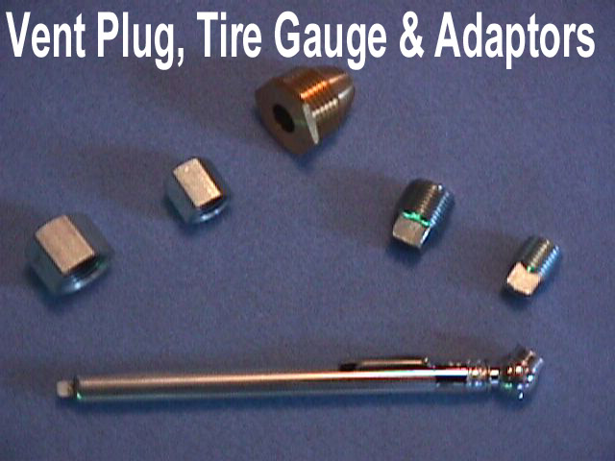

Tire Pressure Gauge: P/N-01675 This pressure gauge permits service personnel to check for the proper inflation pressure on various pneumatic wheel types. The gauge has a durable metal outer case and provides pressure readings in 1 pound increments.

Plug and Cap Set: P/N-01805 This specially selected set allows service technicians to perform maintenance on special extinguisher models were the isolation or plugging of some fittings is necessary. The steel service kit plugs and caps are all plated for long life. The set is especially selected and designed for quick field installation and removal using a common adjustable wrench.

Kit Box with Inserts: P/N-01620 The box holds and stores all the service kit items so they will not get lost and comes equipped with special foam rubber inserts to safely protect the gauged components. The durable box is corrosion resistant and equipped with plated metal latch.

